|  |
| --- |
| COVID-19 Chatbot  User Manual |
|  |
| ISY5001 Intelligent Reasoning Systems  A0213481M Lim Wee Kiat  A0124453M Eu Jin Marcus Yatim  A0213501B Teoh Yee Seng |

Table of Contents

Application 3

1. Download Telegram on your device 3

2. Register for Telegram 3

3. Search for @covidchatbot 4

4. Features of @covidchatbot 5

Deployment 21

1. Django 21

2. ngrok.exe 22

3. Telegram BotFather 22

4. Dialogflow 23

5. Get Started 23

6. Making Announcement 23

Additional Note 24

# Application

## **1.** Download Telegram on your device

If you are using your mobile device, download:

Telegram for Android (Google Play)

Telegram for iPhone and iPad (App Store)

If you are using your computer, download:

Telegram for Windows/Mac/Linux

Visit <https://telegram.org/apps> for download links.

## 2. Register for Telegram

Once you have downloaded Telegram on your device, open the app.

You will need a phone number to create an account. Tap on ‘Start Messaging’ button to enter your phone number. As soon as you enter the number, you’ll get an OTP. Enter that code into the app to continue.

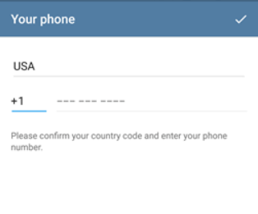

Telegram will ask you to set up your first and last name. Enter this information to continue.

## 3. Search for @covidchatbot

Once inside Telegram’s main page, click the search bar at the top left corner and type in “@covidchatbot”.

The display name of the chatbot is also called “David-19”.

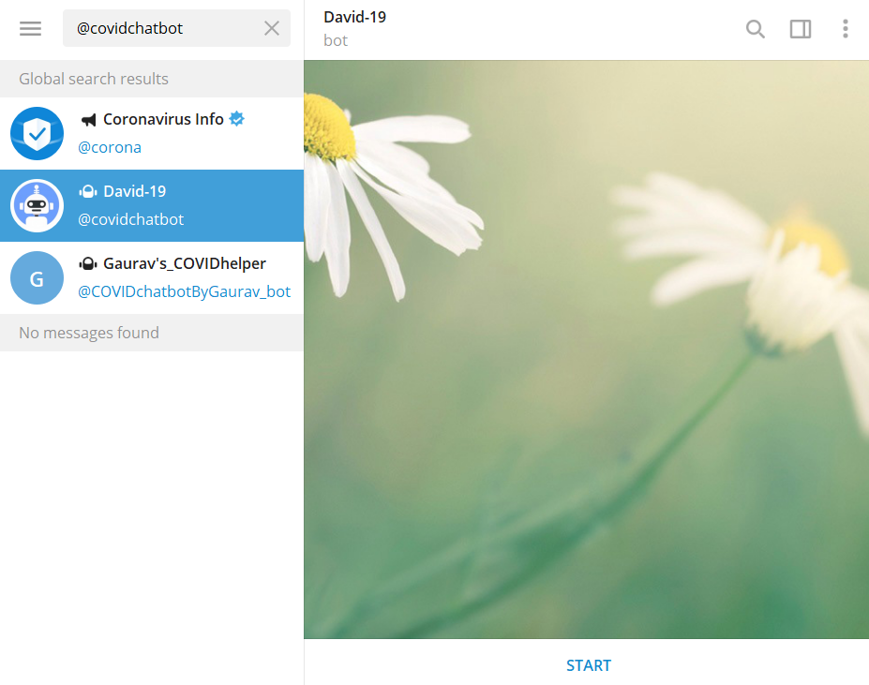

To begin, click on the ‘Start’ button at the bottom.

## 4. Features of @covidchatbot

The chatbot has many features, as explained in the Welcome message.

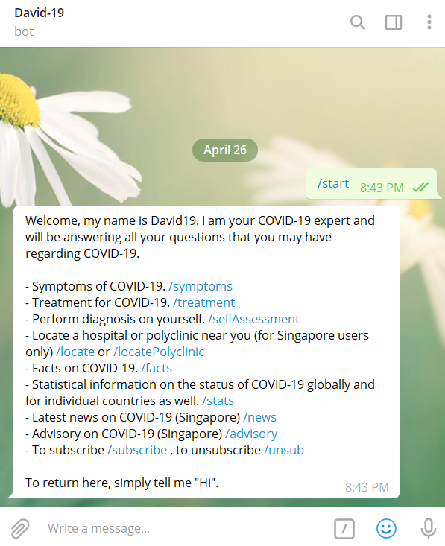

To access any of the features, either click on the blue-highlight tags (e.g. /symptoms, /treatment, etc.) or type in any question / sentence / word(s) that can be associated with the feature.

Symptoms Feature

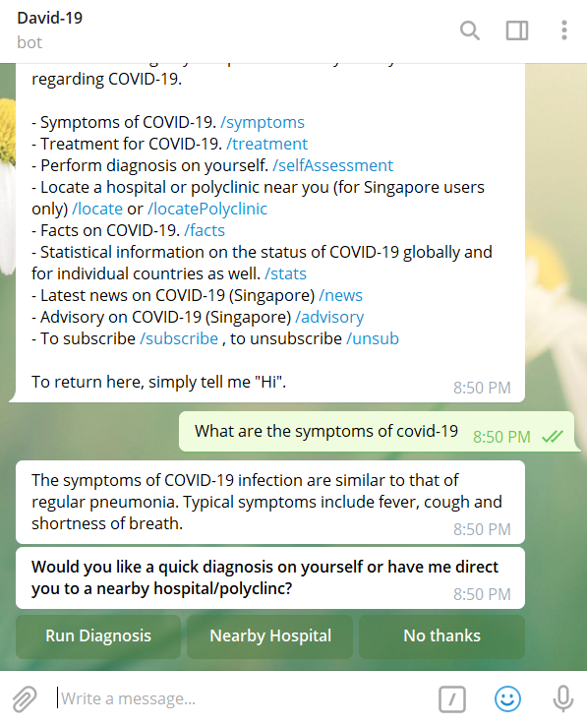

Typing in the command “What are the symptoms of covid-19” will lead you to the Symptoms feature. Try typing in “What symptoms are there”, “symptoms” or any sentence or words to that effect, to similarly access the Symptoms feature.

Follow the buttons on screen to either access the Self-Assessment feature (“Run Diagnosis”) or the Locate feature (“Nearby Hospital”).

Treatment Feature

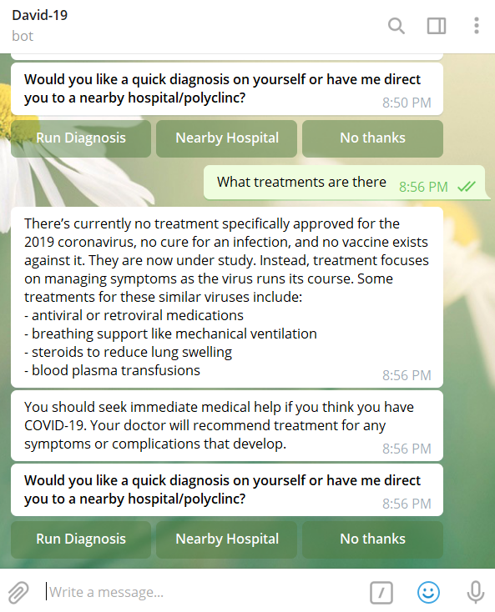

Typing in the command “What treatments are there” will lead you to the Treatment feature. Try typing in “What are the treatment for covid-19”, “treatment” or any sentence or words to that effect, to similarly access the Treatment feature.

Follow the buttons on screen to either access the Self-Assessment feature (“Run Diagnosis”) or the Locate feature (“Nearby Hospital”).

Self-Assessment Feature

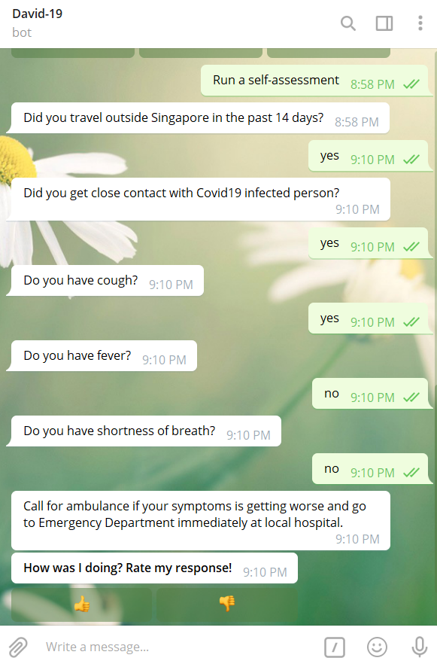

Typing in the command “Run a self-assessment” will lead you to the Self-Assessment feature. Try typing in “Perform a self-assessment”, “self-assessment” or any sentence or words to that effect, to similarly access the Self-Assessment feature.

The chatbot will list a series of questions to perform a simple diagnosis for you. Starting with “Did you travel outside Singapore in the past 14 days?”. Simply reply to the chatbot with a “yes” or “no” to continue. The chatbot will then provide a suitable recommendation based on your responses.

The chatbot also has a “smart feature” where it will know when to send regular checks to ask questions on whether you would like perform another self-assessment, by learning from the queries you send to it

Locate Feature

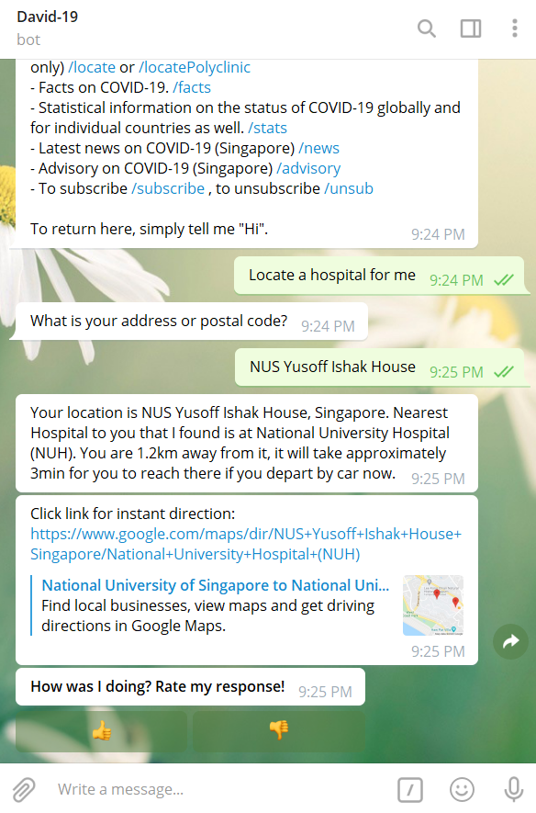

Typing in the command “Locate a hospital for me” will lead you to the Locate feature. Try typing in “Locate hospital”, “locate” or any sentence or words to that effect, to similarly access the Locate feature.

The chatbot will ask for your address or postal code to give you directions to the nearest hospital.

Likewise, you can phrase the command as “Locate a polyclinic for me” if you wish to go to a polyclinic.

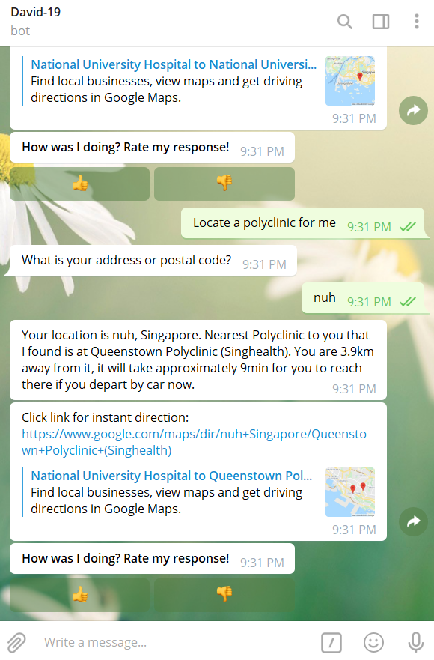

Facts Feature

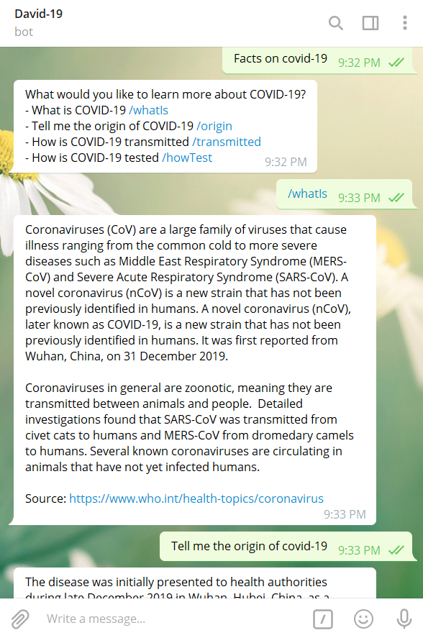

Typing in the command “Facts on covid-19” will lead you to the Facts feature. Try typing in “Give me some facts”, “facts” or any sentence or words to that effect, to similarly access the Facts feature.

The chatbot will ask you a follow up question to find out what sort of facts you would like to know. Click on the blue-highlighted words, or type in the question to be asked to find out the information you require.

Stats Feature

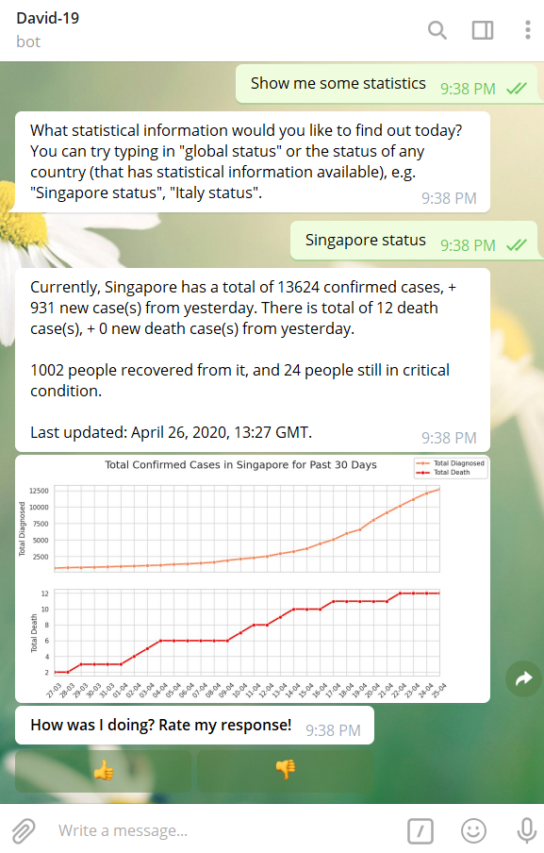

Typing in the command “Show me some statistics” will lead you to the Stats feature. Try typing in “Give me some stats”, “statistics” or any sentence or words to that effect, to similarly access the Stats feature.

The chatbot will ask you a follow up question to find out which country’s statistics you wish to view. Type in the name of the country, followed by “status”. E.g. “Singapore status”, “Malaysia Status”, “Italy Status”, etc.

News Feature

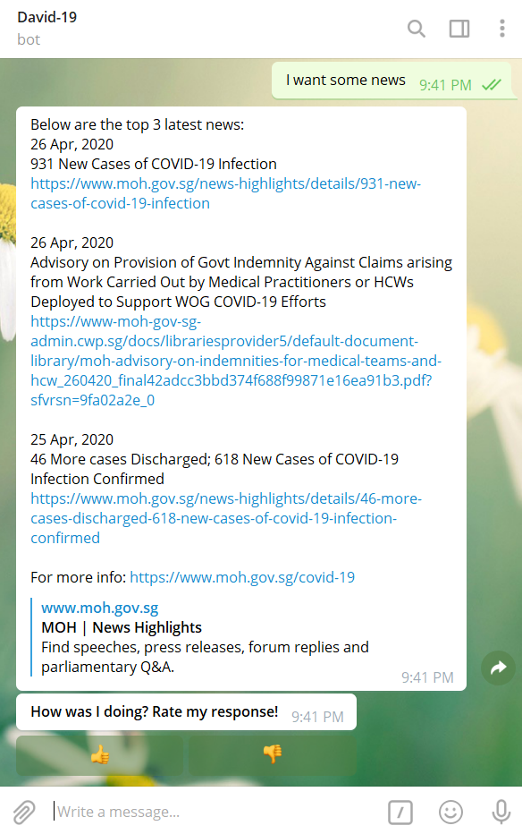

Typing in the command “I want some news” will lead you to the News feature. Try typing in “Give me some news”, “news” or any sentence or words to that effect, to similarly access the News feature.

Advisory Feature

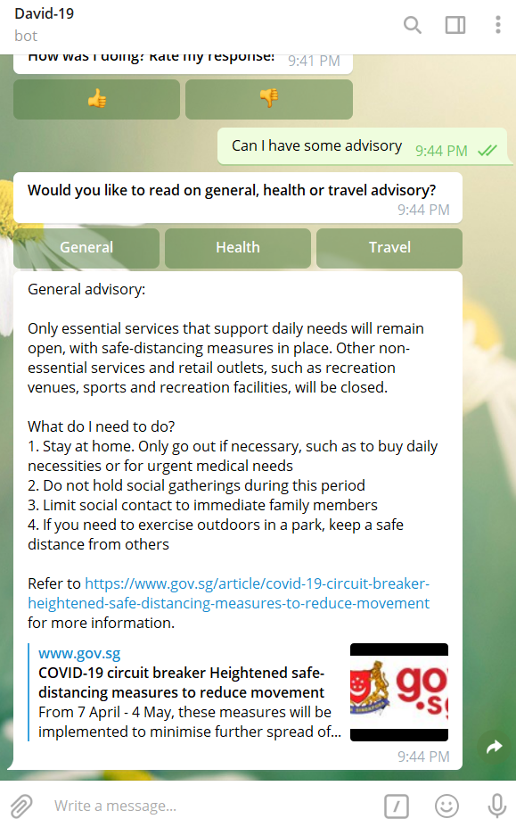

Typing in the command “Can I have some advisory” will lead you to the Advisory feature. Try typing in “I want some advisory”, “advisory” or any sentence or words to that effect, to similarly access the Advisory feature.

The chatbot will show you three buttons to select the type of advisory it can provide: “General”, “Health” and “Travel. Click on the respective buttons to get said advisory.

Alternatively, you can also type in the form of advisory directly to query it.

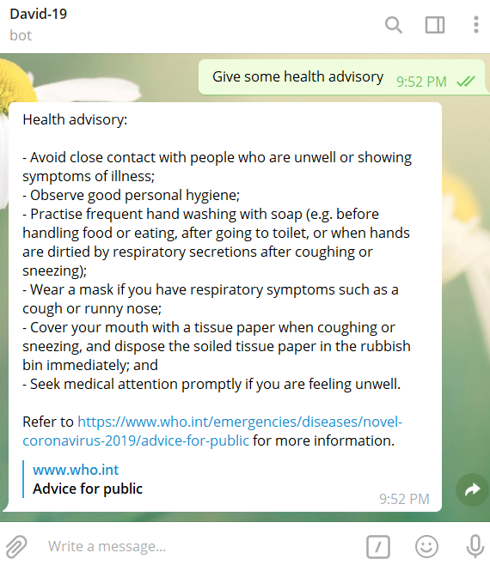

Subscription Feature

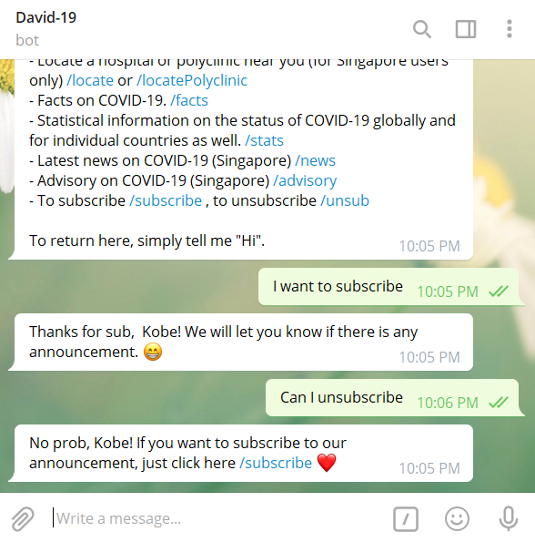

Typing in the command “I want to subscribe” will lead you to the Subscription feature. Try typing in “Can I subscribe”, “subscribe” or any sentence or words to that effect, to similarly access the Subscription feature. Likewise, for unsubscribing to the chatbot.

Subscription to the chatbot will allow you to receive push notifications on any latest news updates. By default, a new user is automatically subscribed to the chatbot.

Note: If you are admin trying to send announcement, refer to Deployment section.

Feedback Feature

Last but not least, you would have noticed that most features have a feedback prompt, where a message to ask you to rate the response is asked. Simply click the thumbs up or thumbs down button to indicate your satisfaction with the feature.

Your input is greatly appreciated!

# Deployment

This document is about how to deploy the COVID-19 Chatbot. The chatbot requires the set-up of several components, namely:

* ngrok.exe
* Telegram BotFather
* Dialogflow
* Django

This document will not go through how to use the chatbot on Telegram, as information on that can be found in the User Guide.

Before beginning, clone or download our GitHub repo from <https://github.com/nus-isy5001-wym/IRS-MRS-2020-01-18-IS02PT-GRP6-COVID-Chatbot>.

## 1. Django

Before you get started with Django, ensure that Python is installed on your system.

Download and install Python from: <https://www.python.org/>.

Once Python is setup, download the entire project’s course code under “System Code” on the GitHub repo into a directory of your choice.

Next, you need to install all dependencies required for this project. Refer to the requirements.txt file inside the GitHub repo as well to ensure that you have the required Python libraries installed. Simply open a terminal and run the command line  followed by the name of the library appended to the end.

In the same terminal,  to the directory of your choice, where “manage.py” file is located. Run the following command:



## 2. ngrok.exe

Download ngrok.exe for your system from <https://ngrok.com/>.

Once downloaded, execute the ngrok.exe file and a terminal window will open. Type in the following command line:



Take note of the temporal forwarding URL, as shown highlighted in the example screenshot below:

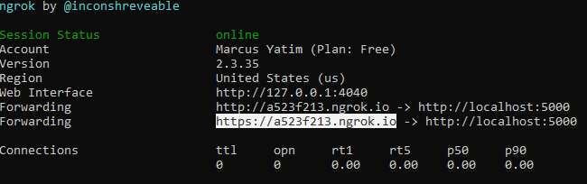

## 3. Telegram BotFather

Ensure you have Telegram installed. Go to <https://telegram.org/apps> to install Telegram for your device. Once installed, set up a Telegram account as well.

Once inside Telegram, type BotFather in the search bar and click on the verified, official BotFather (it will have a blue tick beside its name).

Type ‘/newbot’ in the input bar and follow the on-screen instructions to create your bot.

Take note of the token to access the HTTP API.

## 4. Dialogflow

Go to Dialogflow at <https://dialogflow.com/>. Register for a Dialogflow account using a set of Google user credentials.

Create a new agent. Once created, click to the Export and Import tab in the settings of your agent and click Import From ZIP.

Before moving on, take note that our COVID-19 Chatbot agent zip file, COVIDChatbot.zip, can be found in the Miscellaneous folder of the GitHub repo.

Follow the onscreen instructions in Dialogflow to upload the COVID-19 Chatbot agent zip file.

Go to the Fulfillment option on the menu access on the left. Ensure the Webhook is enabled and also change the URL path to the temporal forwarding URL generated by ngrok.exe in the first step. E.g. <https://a523f213.ngrok.io>.

Got to the Integrations option on the menu access on the left. Click on Telegram and input the previously acquired token from the previous step.

## 5. Get Started

Congratulations, you have successfully deployed the COVID-19 Chatbot! Head over to Telegram and start using your newly created bot in Step 3, now with all the functionalities of the COVID-19 Chatbot.

## 6. Making Announcement

From project directory where the source codes are located, go to announcement folder. You will find:

* announcement.py python file
* bot_token.txt text file
* message.txt text file

|  |  |
| --- | --- |
|  | Open up bot_token.txt file, and paste your Telegram bot token into the text file. Make sure to leave no spaces behind.  Then, open up message.txt file and write your personalized message that you want to send to all your users that have subscribed to your bot channel.  From your command prompt terminal,  to the announcement folder, and run “python announcement.py”.  Note: This will send your message in “message.txt” to your bot declared in ”bot_token.txt” to all the users registered in your Django database. You can easily view the user list from http://127.0.0.1:5000/user_list/ |

## Additional Note

Instead of ngrok, you may consider using other PaaS (Platform as a Service) such as Heroku, AWS, Azure, etc, that better suit your needs.